With random forest, first 1000 and last 1000 points of each fault period (fault 1) as training set, train the model and then use the whole data set as the input to predict all the labels. The result is shown below, where nine subplots are each individual fault period. Simple conclusion can be reached that the fourth period can be predicted well but the rest are not so well. The third period is also acceptable.
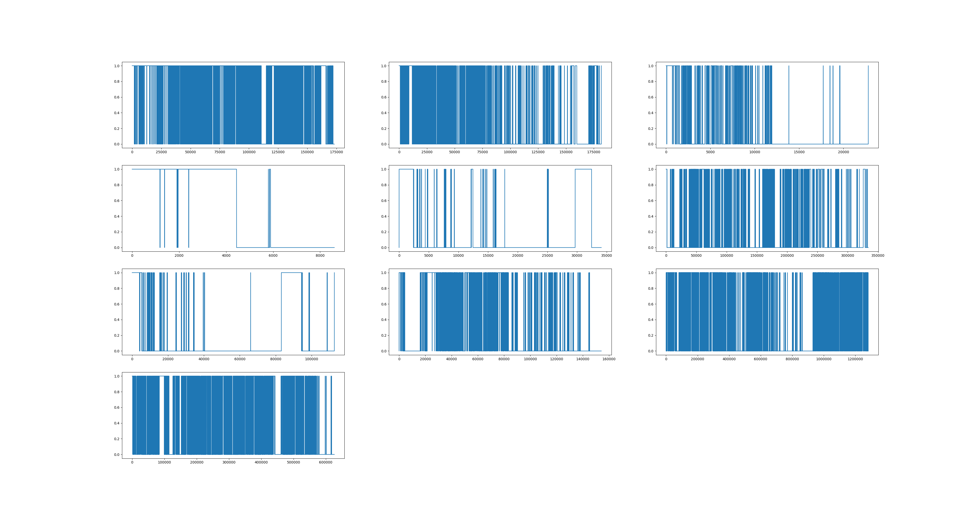
The figure below shows a closer look at each period, all fixed to the last 8000 points before failure, where we cannot simply conclude that the random forest is performing well at the final stage of the failure although the training error is small. But still we can say that at least we are capable of classifying the healthy status and degrading status.
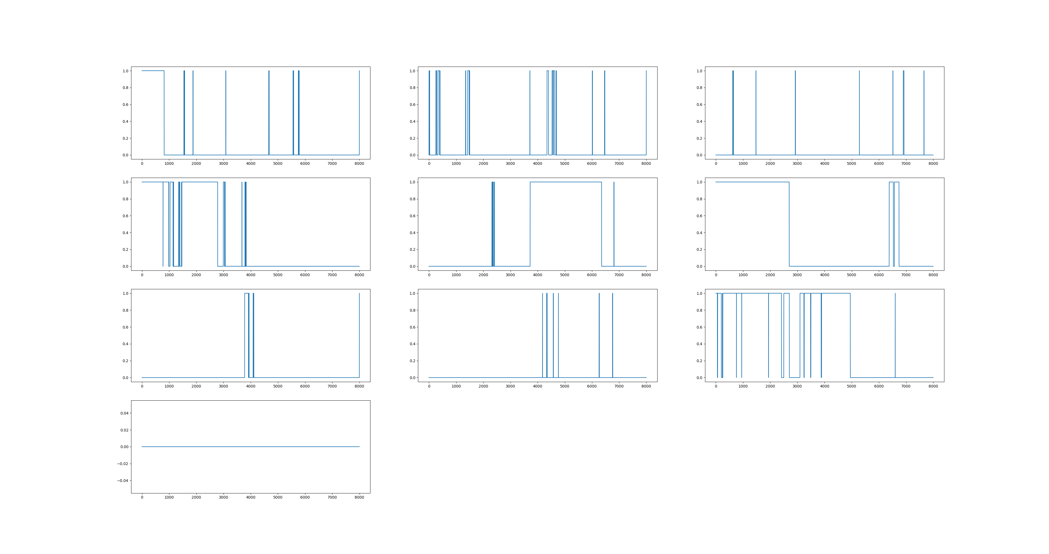
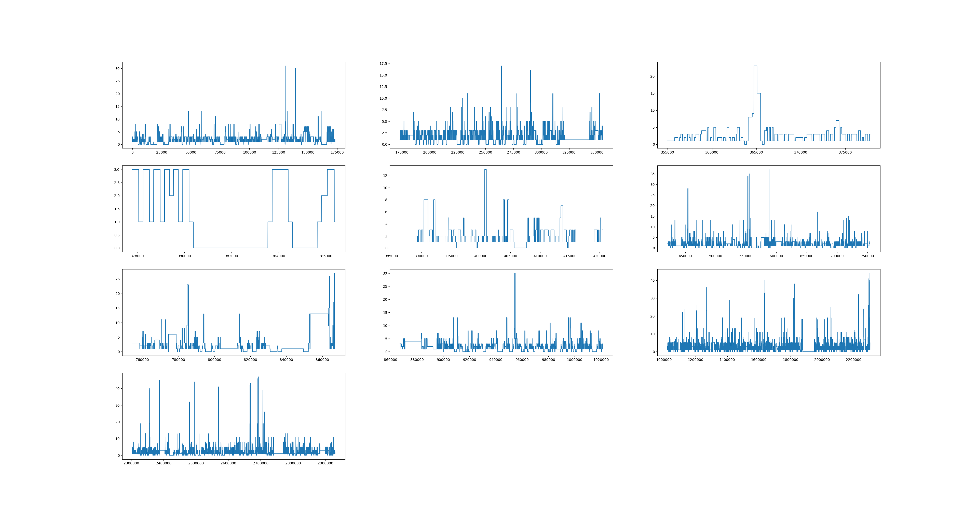

The figure above is the plot of [recipe] in the corresponding periods. I am making an assumption that the more unified recipes are in one period, the more accurate that the classifier can give us the result. (By comparing the fourth period the third period with the others. It seems like those two period consist of few recipes and the classifier performs well)

Conclusion and next step:

1) we are able to classify the initial healthy state and the final failure state, so the next step will be applying logistic regression and try to fit a curve that can indicate the health index.

Training would take all the data in one unit (01M01) as input, and the data is going to be batched with fault period, so for each period, we want to find a logistic regression curve (by ignoring the last layer of logistic regression where it output the 0/1 classes) for all the periods.

2) At the same time when we are doing step (1), the working conditions need to be clustered. The basic idea would be clustering them using [rms, max, mean, duration] those four features.
The working conditions here means the different combination of [recipe] and [stage].

After clustering them, we will try to separate the data into different conditions and try to get different logistic regression curves to fit them.

Problems:
The way of determining the initial predicting value (aka the initial RUL) is still unknown. From the papers, it seems like they are finding this initial value by minimizing their loss functions. And PhD said that there is no way to know how much time actually left with current time and past time information. The only way to do it is finding the point of degradation and predict the failure time.

